## Delroy Nichols

Data 716

Prof. Rhindress

11/19/2024

## **From Recruiting Analytics to Recruiting Success: Development of a College Football Recruiting Dashboard**

**Abstract:** In the competitive world of collegiate athletics, Division I football programs are constantly striving to attract top high school athletes to their programs. To facilitate this process, many institutions have implemented recruiting databases that provide a centralized platform for tracking and managing their recruiting efforts. This paper presents the development of a nationwide recruiting dashboard specifically designed to integrate those large databases with data from the various subscribed recruiting services. The recruiting dashboard developed in this paper provides a valuable tool for universities and colleges to effectively manage and oversee their organization-wide recruiting efforts. By building on these intuitive and user-friendly operational models, institutions can enhance their ability to attract top high school athletes and achieve their recruiting goals.

**Objective**

My vision, actually, our vision is to develop a cutting-edge recruiting dashboard that empowers college football programs to dominate the competition. This isn't just about streamlining processes; it's about revolutionizing how teams identify, evaluate, and secure top talent. We're talking about a competitive advantage that will redefine the recruiting landscape.

**Enhancing Efficiency and Productivity**

Time is of the essence in the high-stakes world of college football recruiting. Our dashboard will centralize all recruiting data available to high-power Division I programs—profiles, academics, evaluations, overall recruiting progress, communication metrics—into a single, easily accessible command center. We are driven to eliminate the chaos of scattered information and empower coaches with instant access to critical insights on their prospects. As we evolve, we'll incorporate advanced features like automated task management, dynamic recruiting calendars, and real-time progress tracking throughout the entire recruiting journey tailored to specific programs. This is about maximizing efficiency inside the football building and ensuring that every minute a coach spends is dedicated to securing the very best talent.

**Enabling Data-Driven Decision Making**

In the era of big data, intuition isn't nearly enough. Our dashboard integrates data from every relevant source—scouting services, NCAA databases, social media, and in-house evaluations—to provide a 360-degree view of each prospect. We go beyond basic statistics, offering advanced analytics and reporting tools that delve into past performance, statistics, identification of emerging trends, and evaluate the effectiveness of recruiting strategies. Forget static reports; we'll present data through dynamic visualizations—heatmaps, scatter plots, histograms, Sankey diagrams—that instantly communicate key insights and empower coaches to make informed decisions on the fly.

**Optimizing Resource Allocation**

Every scholarship offer, every campus visit, every coach's call is an investment. Our dashboard ensures those investments yield maximum returns. We'll enable coaches to laser-focus on prospects who perfectly match the program's needs and playing style. Imagine a system that dynamically adjusts recruiting ranges based on real-time feedback, competitor activity, and historical trends. We'll optimize travel schedules, manage scholarship offers strategically, and track return on investment (ROI) with laser precision. This is about more than just efficiency; it's about ensuring that every resource is deployed strategically to secure the most valuable assets.

**Improving Recruiting Outcomes**

Our dashboard isn't just about managing data; it's about transforming data into victories. We'll minimize the time wasted on prospects outside the program's realistic reach, allowing coaches to focus on building relationships with top targets. This means personalized communication, AI-powered call suggestions, and a deep understanding of each recruit's motivations and preferences. We're not just building a tool; we're building a talent acquisition powerhouse.

**Action Standard**

**Market Opportunity**

College football is a multi-billion dollar industry where the battle for talent is fierce. Recruiting is the lifeblood of any successful program, and the demand for innovative solutions is skyrocketing. Big data and analytics has already targeted the college football industry successfully, however, much of that revolution has addressed what happens on-the-field. Those staff members who specialize in performance off-the-field are becoming more and more reliant on data-driven insights to evaluate players and make precise strategic decisions. Our dashboard addresses this need comprehensively, providing an integrative platform that can meet the demands of the modern recruiting landscape.

**Market Need**

Traditional recruiting methods are no longer enough. Coaches are drowning in a sea of data from disparate sources—scouting services, academic records, X(twitter)—and struggling to manage these inefficient workflows. Existing solutions, more times than not, lack the ability to generate simple and intuitive visualizations; let alone provide the advanced analytics needed to effectively communicate key insights. Our dashboard solves these problems, offering a centralized, user-friendly platform that streamlines processes, enhances communication, and empowers data-driven decision-making for every member of the recruiting staff to utilize at its capacity.

**Target Audience**

Our target audience is every ambitious college football program, from the biggest names in the FBS to rising stars in the FCS. We recognize that different roles within a program have unique needs. Head coaches crave a macro-view of talent evaluation and roster management, while position coaches need granular insights into specific skills, scheme fit, and individual-level recruitability. Our dashboard caters to these diverse needs, offering a customizable and scalable solution that adapts to any program's structure and goals.

**Competitive Landscape**

We're not the first to enter the recruiting software arena, but we're here to disrupt the status quo. Existing solutions like Front Rush, ARMS Software, and Hudl offer valuable features, but they often fall short in terms of data integration, advanced analytics, and user experience. Our dashboard will work with your existing data warehouses and differentiate itself through cutting-edge technology, a user-centric design philosophy, and a relentless commitment to innovation.

**Value Proposition**

Our value proposition is simple: We help college football programs win. The dashboard streamlines workflows, centralizes information, and automates tasks, freeing up coaches to focus on what they do best: building relationships and developing talent. We provide the tools and insights needed to make data-driven decisions, optimize resource allocation, and achieve recruiting dominance.

**Market Size and Growth Potential**

The market for recruiting software in college football is exploding. Driven by the increasing adoption of analytics, the rise of the transfer portal, and the growing importance of data-driven recruiting, this market is poised for exponential growth. Our dashboard is strategically positioned to capitalize on this trend, offering a solution that meets the evolving needs of college football programs and drives future success.

**Product and Technology**

Forget clunky spreadsheets and scattered information. Our cutting-edge recruiting dashboard is designed to streamline your process and give you a winning edge.

*Dashboard Features.* We've packed it with powerful tools, from state-to-state recruiting comparisons and film breakdown feedback modules to academic progress trackers and communication metrics. It's your one-stop shop for managing every aspect of recruiting, perfect for Head Coaches that wan’t an overview of their current and past recruiting activity.

*Data Integration.* Seamlessly integrates data from scouting services, ARMS databases, and even social media. Get a 360-degree view of every recruit, all in one place.

*Scalability and Security.* Built on a robust and secure platform, our dashboard can handle massive amounts of data from the services you’ve already invested in and grow as your program grows. Rest assured, your sensitive information is protected.

*User Experience.* Intuitive and user-friendly, our dashboard is designed for coaches, not tech wizards. Spend less time wrestling with technology and more time finding the next superstar. Gone are the days of hiring a full-time employee just for database management, save money and let us take care of that for you. Thank us later.

### **Team and Execution: Assembling our A-Team**

We're not just tech geeks; we're football fanatics who understand the recruiting game. Our team boasts a unique blend of software developers, data engineers, and former coaches who have walked in your shoes. We're passionate about building a product that gives you a decisive advantage.

**Go-to-Market Strategy**

We're hitting the ground running, connecting with coaches and athletic departments across the country. As a former salesman myself, I will be at the front lines leading the charge for consistent revenue. Starting with smaller FBS programs to those FCS schools looking to expand their recruiting; our targeted approach ensures that our dashboard reaches the programs that need it most.

**Product Roadmap**

This is just the beginning. We're committed to continuous innovation, adding new features and integrations based on your feedback. Our roadmap is driven by your needs, ensuring that our dashboard remains the gold standard in college football recruiting. This includes an advanced analytics platform for Head Coach Quality Control needs, Recruiting Coach Travel Partner Mobile App, and interactive user interface that will be frequently updated with new designs and features.

### **Financial Projections and Investment Considerations: A Slam Dunk Investment**

Forget the bleachers, let's talk boardroom, let’s talk behind the scenes even. This isn't some Hail Mary startup; it's a calculated investment with a clear path to market dominance. We've strived to find a gap and now have engineered a revenue model that's as strong as your future offensive line, designed to score big with college football programs of all sizes.

**Revenue Model: Subscription Tiers for Every Program**

Think tiered subscriptions, like your favorite streaming service, but for recruiting dominance. Whether you're an FBS powerhouse or a rising FCS contender, we've got a budget-friendly package that delivers immediate value to your program.

* **Scout:** Perfect for smaller programs or those just starting with data-driven recruiting. Provides essential tools at an affordable price point.
* **Pro:** Ideal for mid-major programs or those seeking a competitive edge. Includes advanced analytics and reporting features.
* **Champion:** Designed for elite programs seeking the ultimate recruiting advantage. Offers the full suite of features, including AI-powered scouting and predictive analytics.

This translates to recurring revenue, high customer lifetime value, and expansion opportunities within athletic departments. We're not just selling software; we're building long-term partnerships.

**Financial Projections: 5-Year Growth Trajectory**

We've run the numbers, analyzed the playbook, and mapped out our winning strategy. Our 5-year projections show explosive growth, fueled by rapid customer acquisition and strong retention rates.

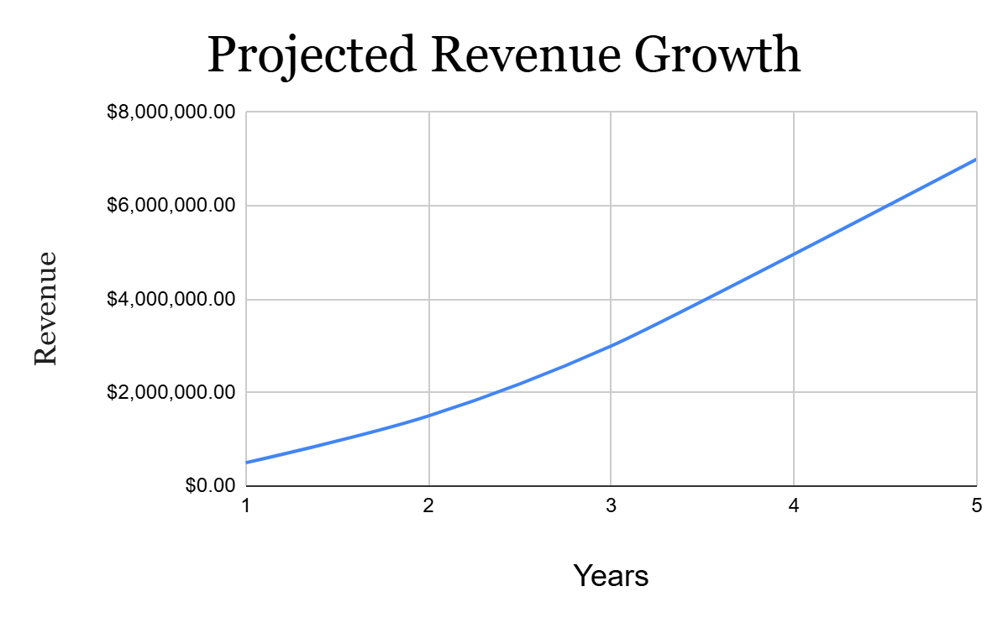

* **Year 1:** Phase for Early Adopters and building market share. Projecting $500,000 in revenue.
* **Year 2:** Expand sales and marketing efforts, targeting larger programs. Projecting $1.5 million in revenue.
* **Year 3:** Achieve profitability and expand product offerings(mentioned in the Foreword). Projecting $3 million in revenue.
* **Year 5:** Establish market leadership and solidify recurring revenue streams. Projecting $7 million in revenue.

We're projecting $7 million in annual recurring revenue by year 5, with a clear path to profitability within 24 months. This is a high-growth opportunity with a massive, untapped market.

**Investment Terms: Partner with Champions**

We're seeking strategic partners who share our passion for innovation and are ready to dominate the college football landscape. We're offering what you need, a limited opportunity to join the A-Team of college football recruiting.

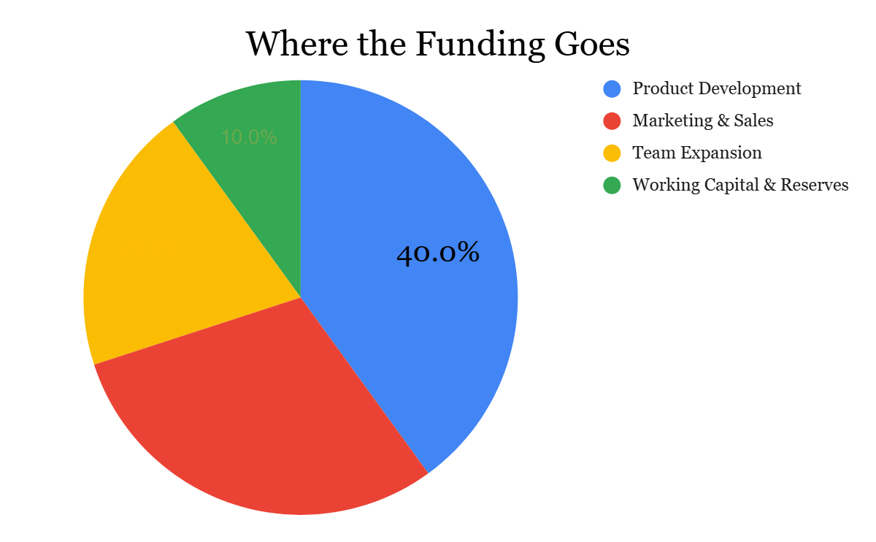

We're seeking 2 million dollars to fuel our growth and solidify our position as the leader in college football recruiting technology. This investment will be strategically allocated to:

* **Enhance product development:** Expand our feature set, integrate AI-powered scouting, and develop cutting-edge analytics.
* **Amplify marketing and sales:** Reach more programs, build brand awareness, and establish strategic partnerships.
* **Expand our team:** Recruit top talent in software development, data science, and sales to accelerate growth.
* **Strengthen infrastructure:** Invest in robust technology infrastructure to support scalability and security.

This is your chance to get in on the ground floor of the next big thing in sports tech.

Don't miss out on this opportunity to score big. Join us as we revolutionize college football recruiting and build a championship-caliber program, both on and off the field.

**Methodology**

This study utilizes an **explanatory sequential mixed methods design**. This involves collecting and analyzing qualitative data first, followed by quantitative data collection and analysis. The qualitative findings inform the design and focus of the quantitative phase, allowing for a more targeted and insightful investigation.

**Qualitative Phase**

*Focus Groups*: Six focus groups were conducted, involving 48 participants from diverse roles within college football programs, including head coaches, assistant coaches, recruiting coordinators, and operations staff. Participants were selected through purposive sampling, ensuring they had relevant experience in recruiting and were willing to share their insights. The focus groups were designed to capture a range of perspectives on the current recruiting processes, challenges, and the potential utility of a recruiting dashboard.

*Focus Group Protocol*: A semi-structured interview guide was developed, focusing on four primary areas: (1) the current recruiting processes and challenges faced by participants, (2) the desired features and functionalities of a recruiting dashboard, (3) the perceived importance of various recruiting variables (such as rankings, location, and athletic measurables), and (4) the ways in which data visualization could support decision-making. The semi-structured nature of the interviews allowed for flexibility in responses, while still ensuring consistency in addressing key research questions.

*Data Collection and Analysis*: Each focus group session was audio-recorded and subsequently transcribed verbatim for analysis. Thematic analysis was employed to identify recurring patterns, themes, and key insights from the transcripts. The analysis process involved two researchers independently coding the data. Any discrepancies in the coding were resolved through discussion and consensus to ensure the reliability and validity of the findings.

**Quantitative Phase**

*Survey Development*: Building upon the qualitative findings, a 60-item survey was developed to further investigate the preferences and perceptions of a broader group of college football coaches. The survey included a combination of closed-ended questions (multiple choice and Likert scale) and open-ended questions. The closed-ended questions assessed the importance of various recruiting factors, preferences for dashboard features, and satisfaction with potential dashboard designs. The open-ended questions provided participants with the opportunity to elaborate on their responses, offering richer qualitative insights.

*Survey Administration*: The survey was administered electronically to a larger sample of 500 college football coaches, recruited through professional organizations and online platforms. The sample included coaches from various divisions (FBS, FCS) to ensure diverse perspectives were captured.

*Data Analysis*: Descriptive statistics were used to summarize the responses to closed-ended questions, providing an overview of the preferences and opinions of the respondents. Additionally, multi-factorial analysis of variance (ANOVA) was conducted to examine the effects of coaching role (head coach, assistant coach, coordinator), program division (FBS, FCS), and years of experience on preferences for dashboard features and recruiting variables. Open-ended responses were analyzed thematically, complementing the quantitative findings by identifying key themes and providing deeper context for the numerical data.

**Themes and Findings**

1. **Data Overload and Fragmentation:**

Coaches expressed a strong degree of frustration with the sheer volume of data they encounter during the recruiting process. Information gets scattered across various platforms with differing formats, making it entirely too difficult to get a complete picture of a recruit.

"It's like drinking from a firehose. You've got scouting notes, highlight films, transcripts, social media, guys in your own office who might’ve seen the kid... it's impossible to keep track of it all." - *Assistant Coach, FBS Program*

1. **Inefficient Workflows and Time Constraints:**

Current recruiting processes are often manual and time-consuming. Coaches spend countless hours on administrative tasks, leaving less time for evaluating talent and building relationships with recruits.

"I spend more time updating spreadsheets and chasing down information than I do actually watching film and talking to kids because I have to do the front-end work to ensure my time isn’t wasted." - *Recruiting Coordinator, FCS Program*

1. **Subjectivity and Bias in Evaluation:**

Coaches acknowledged the inherent subjectivity in evaluating talent. Biases, personal preferences, and limited information can lead to missed opportunities or recruiting mistakes.

"Sometimes you fall in love with a highlight reel, but then you see the kid in person and he's not what you expected. Or you overlook someone because they don't fit the mold." - *Head Coach, Division II Program*

1. **Desire for Centralization and Visualization:**

Coaches expressed a strong desire for a centralized platform that consolidates all recruit data and presents it in a clear, easily digestible format. Visualizations, such as comparison tables and heatmaps, were seen as crucial for quick and effective decision-making.

"If I could see all the key information on one screen, compare high schools side-by-side, and visualize how many recruitable kids are on their roster, I’d be multiple steps ahead of every coach on the road." - *Offensive Coordinator, FBS Program*

1. **Embracing Data-Driven Decision Making:**

Coaches recognize the growing importance of data in recruiting. They are eager to leverage analytics and predictive modeling to gain a competitive advantage and make more informed decisions.

"We need to be smarter about how we evaluate talent. Sometimes a kid looks good because he’s surrounded by duds, then you get him on an official visit and he’s 3 inches shorter and struggling to shoot a basketball at Dave and Buster’s. A refined data-driven recruiting process can help us identify diamonds in the rough and avoid costly mistakes." - *Head Coach, FCS Program*

**Analysis**

The data from both the focus groups and the survey were triangulated to provide a comprehensive understanding of the factors that influence recruiting decisions and the features desired in a recruiting dashboard. The qualitative phase revealed several recurring themes related to the challenges of current recruiting processes, such as time constraints, data overload, and the difficulty in making data-driven decisions. Participants expressed a strong interest in a dashboard that would streamline these processes and provide easy access to relevant recruiting variables, such as player rankings, geographic location, and athletic measurables.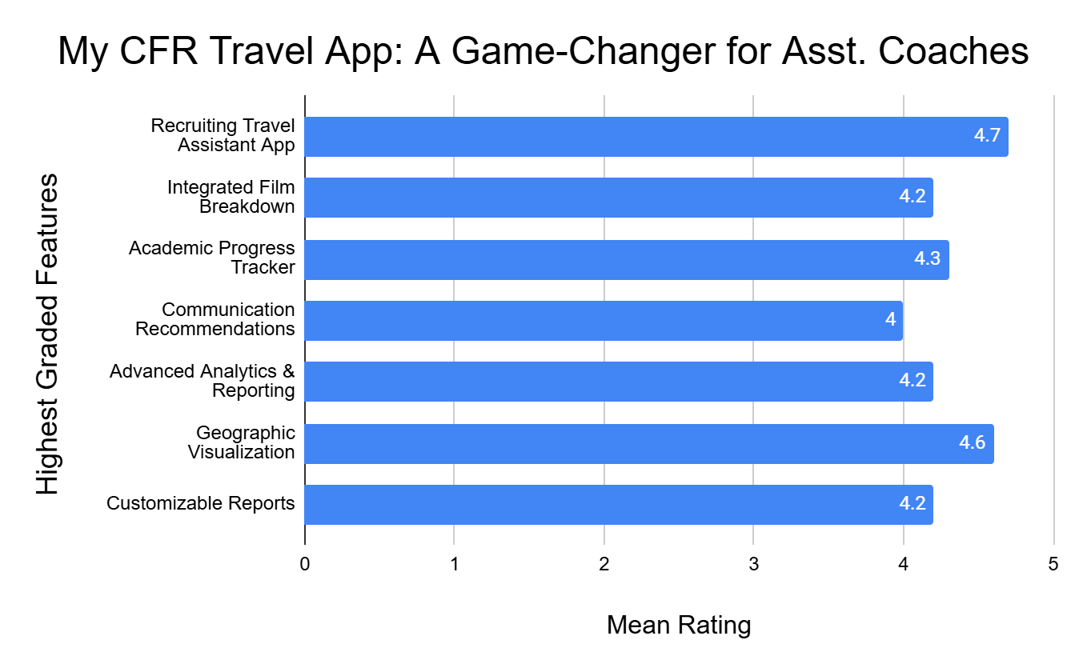

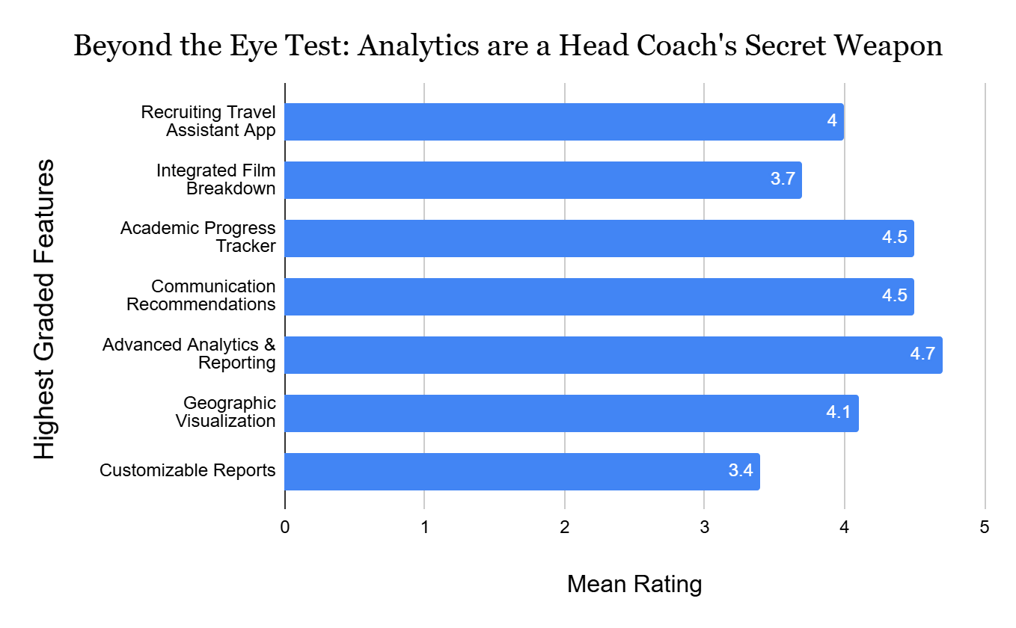

In the survey, the results from the closed-ended questions were consistent with the qualitative findings, with participants ranking the same variables as most important in their recruiting decisions. For example, rankings and location were highly valued, whereas less attention was given to variables such as a player's social media presence. Preferences for dashboard features were also aligned with the qualitative insights, with a significant portion of participants emphasizing the importance of a user-friendly interface, real-time updates, and customizable filters.

**Satisfaction with Current Recruiting Processes** (rated on a 5-point Likert scale, where 1=Very Dissatisfied and 5=Very Satisfied). Mean satisfaction rating: 2.8.

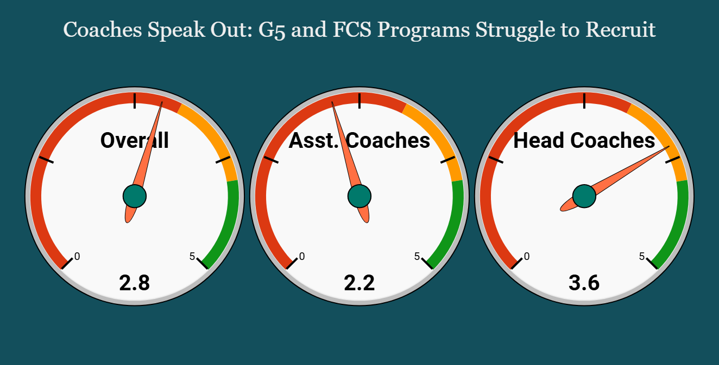

**Willingness to Pay for a Recruiting Dashboard**

78% of respondents indicated they would be willing to pay for a recruiting dashboard. This is an indicator that there is a market gap here that can be reflected as the growing need of analytics in the recruiting sphere.

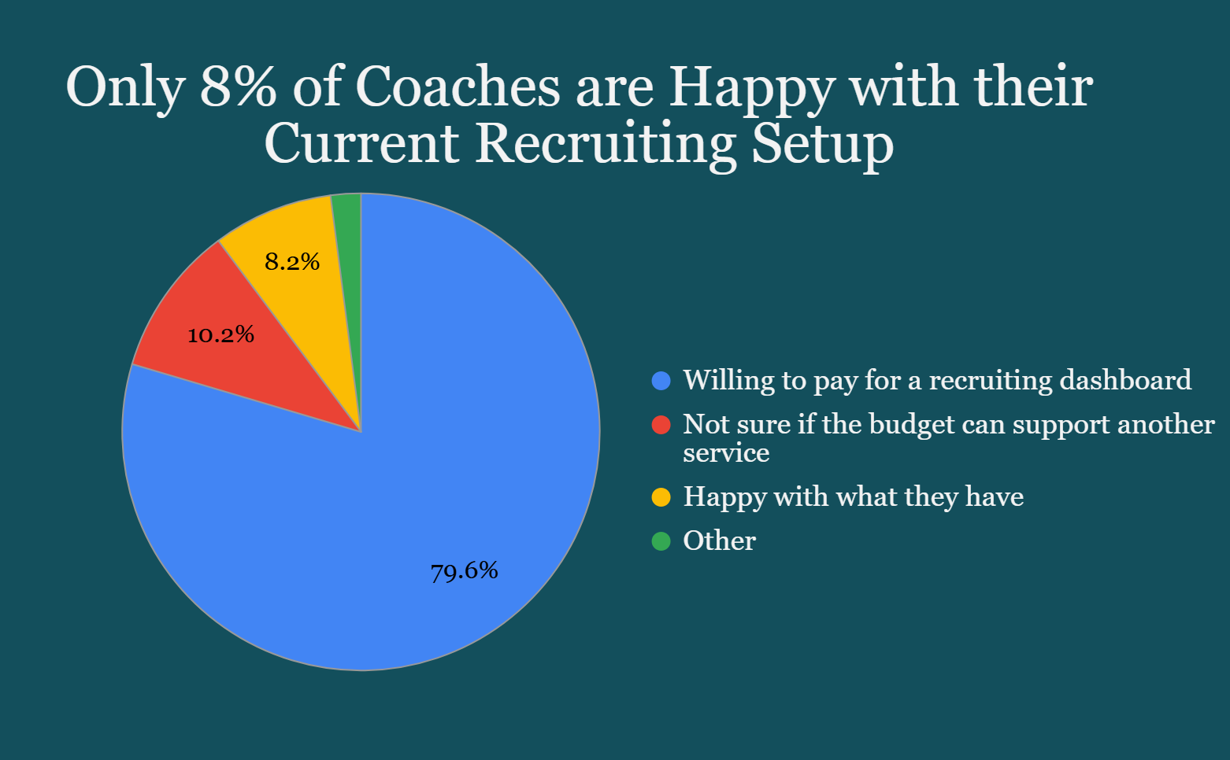

The ANOVA results indicated that coaching role, division, and years of experience significantly influenced preferences for specific features of the recruiting dashboard. For instance, head coaches were more likely to prioritize high-level summary metrics, while assistant coaches and recruiting coordinators favored detailed player data. Coaches from FBS programs were more likely to value advanced analytics compared to those from FCS programs, which could reflect the almost abundant scale of resources available at the FBS level. Additionally, the more experienced coaches expressed a preference for more comprehensive dashboards that included both historical and predictive data, while less experienced coaches preferred simpler, more intuitive designs.

**Discussion**

The mixed-methods approach provided a nuanced understanding of the recruiting challenges faced by college football programs and the desired functionalities of a recruiting dashboard. The qualitative findings revealed a clear need for a solution that could simplify complex recruiting processes, streamline decision-making, and provide easy access to relevant player data. These insights were reinforced by the quantitative findings, which indicated that certain recruiting variables, such as rankings and location, are universally regarded as crucial by coaches across roles and divisions.

Moreover, the study highlighted important differences in dashboard feature preferences based on coaching role, program division, and experience. These variations suggest that a one-size-fits-all approach may not be effective in designing a recruiting dashboard. Instead, dashboards should be customizable to meet the specific needs of different user groups, with features that can be tailored based on role, division, and experience level. For example, head coaches may prioritize high-level overviews, while recruiting coordinators and assistants may need more granular player data.

The study's findings also suggest that data visualization plays a critical role in aiding decision-making. Coaches emphasized the importance of clear, intuitive visual representations of data that could quickly highlight key trends and facilitate comparisons between recruits. This aligns with existing literature on the importance of data visualization in improving decision-making in sports management.

Ultimately, this study contributes to the growing body of research on data-driven decision-making in college sports and provides practical recommendations for developing a recruiting dashboard that meets the diverse needs of college football programs. Future research could explore the implementation of such dashboards in real-world settings, assessing their impact on recruiting efficiency and decision-making accuracy.

**Conclusion**

Look, the writing's on the wall: college football recruiting is ripe for disruption. And we're here to deliver the knockout punch. Our research has proven what every coach already knows – the current recruiting process is a tangled mess of spreadsheets, scouting reports, and gut feelings. It's inefficient, it's outdated, and frankly, it's costing programs wins.

This isn't 1985 anymore. We're in the era of big data, and those who don't embrace it will get left behind. Our recruiting dashboard is the game-changer. It's the ultimate weapon in the fight for top talent.

Imagine this: all your recruiting data – player rankings, evaluations, academic records, social media buzz – centralized in one sleek, intuitive platform. No more sifting through thousands of emails or relying on hunches. We give you the insights to make informed decisions, fast.

Our dashboard isn't just about pretty graphs and charts (though we've got those too, and they're killer). It's about empowering coaches to work smarter, not harder. Identify the recruits that are within your range, compare which recruiting areas provide the most bang for your buck, and predict future roster needs with cutting-edge analytics.

We've talked to the coaches, we've crunched the numbers, and the verdict is clear: this is what they need. They're tired of inaccessible recruiting services that lead to bottlenecks and missed opportunities. They're ready for a solution that gives them a strategic and decisive advantage.

This isn't just about efficiency; it's about winning. With our dashboard, you'll recruit smarter, build stronger teams, and dominate the competition. Period.

Investing in our recruiting dashboard isn't just about buying software; it's about investing in the future of your program. It's about embracing a data-driven approach that will transform your recruiting process and propel you to the top.

The time for change is now. Don't get left on the sidelines. Join the revolution and let's build a dynasty together.

**Foreword**

*Itemized & Detailed Breakdown*

**1. Enhancing Efficiency and Productivity:**

* Centralizing Information: Consolidate all recruit data (profiles, academics, scouting reports, film, communication logs) into a single, easily accessible platform.
  + Coaching Profiles
    - Commitment Rank
    - Avg Calls per Week
    - Recruit APR Score: average apr score per recruit signed
    - Prep Graduation Rank
* Streamlining Workflows: Automate tasks, manage recruiting calendars, and track progress throughout the recruiting journey, from initial contact to signing day.
* Improving Communication: Facilitate seamless communication and collaboration among coaching staff members.

**2. Enabling Data-Driven Decision Making:**

* Integrating Data Sources: Seamlessly integrate data from various sources, including scouting services, NCAA databases, social media, and in-house evaluations.
  + Integrates with Whistle communications platform
* Providing Advanced Analytics: Offer advanced analytics and reporting tools to analyze player performance, identify trends, and evaluate recruiting effectiveness.
* Visualizing Key Metrics: Present data through intuitive visualizations (e.g., heatmaps, scatter plots, Sankey diagrams) that facilitate quick and informed decision-making.

**3. Optimizing Resource Allocation:**

* Targeting the Right Recruits: Enable coaches to identify and prioritize prospects who best fit the program's needs and playing style.
  + Feedback loops within the dashboard will allow coaches a line of communication with FirstLevel scouts in order to communicate where a recruit lands on their board. Personnel staff can rank boards that inform our models which traits are considered most important.
* Planning Efficiently: Optimize travel schedules, manage scholarship offers, and allocate contacts & evaluations strategically.
* Tracking Return on Investment (ROI): Measure the effectiveness of recruiting efforts and identify areas for improvement.
  + Head Coach Quality Control over all assistant coach recruiters.
    - Provides an eagle-eye view as to all aspects of internal recruiting and allows upper management to make informed decisions based on reliable metrics.

**4. Improving Recruiting Outcomes:**

* Enhancing Talent Identification: Leverage data-driven insights to identify and evaluate talent more effectively.
  + Third Party Company All-Inclusive Ranking System
    - Using a variety of sources and all the data at our disposal, an attempt is made to rank the top 5,000 recruits in a recruiting class.
  + Optimal Recruiting Range
    - By Ranking the entire class it is now possible to predict what prospect can be recruited by a specific school given prior history and past recruiting outcomes. As your best recruit gets offered by bigger programs, we adjust the level of certainty/recruitability and adjust their rank. This information is then used to make stronger “who to call” suggestions and make predictions with increased validity.
  + First Level Scouting
    - Preliminary Scouting Effort is made by a personalized scout assigned to a specific school to highlight recruits that are a scheme, program, and academics fit.
      * Data Integration: Use various sources to cross-reference recruiting rank. 100m track times to verify speed. Academic High School Index to cross-reference academic standards and locate pipeline schools.
      * Arms Evaluations clue us in on which schools are pipeline schools.We then verify that with roster data.
* Reducing Haphazard Recruiting: Minimize the time lost of recruiting players who are less likely to commit to your program.
  + ORR allows us to determine who will exist outside of your recruiting range and who is well within your ability to recruit.
* Building Stronger Relationships: Facilitate personalized communication and relationship-building with recruits by suggesting appropriate times to call given the prior call history, recruiting timetable, personal questions that add to the database and increase rapport.
  + Stratified Call Suggestions: AI will give recommendations on proper questions to ask and allow you to register the recruit’s answers for entry into the database.
    - AI will recommend when to call a recruit given a default but modifiable class schedule, time zone, prior recommendations from the prospect and responses from the recruiting database questionnaires.

**5. Gaining a Competitive Advantage:**

* Staying Ahead of the Curve: Provide access to cutting-edge technology and analytics that give programs an edge in the competitive recruiting landscape.
* Adapting to Change: Enable programs to adapt to evolving recruiting trends, such as:
  + transfer portal recruiting that can lead to local recruiting voids.
  + Changes in NCAA rules that speed up the recruiting timeline.
* Maximizing Success: Ultimately, help college football programs achieve their recruiting goals and build winning teams.

**Dashboard Development Timeline**

**Phase 1: Planning & Design (2-3 months)**

* **Qualitative Focus Group Research (2 weeks):**
  + Meet with college football coaches of schools with similar recruiting needs to understand their needs and pain points in recruiting.
  + Determine the key data points they want to track (player stats, academics, film, social media, etc.).
  + Provide initial scouting integration (what data we’ll provide, propose standards around its delivery).
  + Establish success metrics for the dashboard.
* **Data Modeling (3 weeks):**
  + Design the database schema to efficiently store and relate all the necessary data (player profiles, scouting reports, coach notes, communication logs, etc.).
  + Plan data flows between the dashboard, the scouting service, and any other integrations (e.g., NCAA eligibility databases, recruiting databases).
* **Wireframing & Prototyping (4 weeks):**
  + Create wireframes and interactive prototypes to visualize the dashboard's layout, navigation, and user interface.
  + Get feedback from coaches on the design and make necessary iterations.
* **Technology Selection (1 week):**
  + Choose the appropriate technology stack for the front-end (React, Angular, Vue.js), back-end (Node.js, Python/Django, Ruby on Rails), and database (PostgreSQL, MongoDB).
  + Select any necessary third-party APIs or services for features like data visualization, communication, or analytics.

**Phase 2: Development (4-6 months)**

* **Front-end Development (2 months):**
  + Build user interfaces based on approved designs.
  + Develop interactive components for data visualization, filtering, sorting, and searching.
  + Implement user authentication and authorization.
* **Back-end Development (2 months):**
  + Develop the API for data management and communication with the front-end.
  + Build integrations with third-party intelligence services and other data sources.
  + Implement security measures to protect sensitive data.
* **Database Development (1 month):**
  + Setup the database and implement data models.
  + Develop scripts for data migration and maintenance.
* **Testing & QA (1 month):**
  + Conduct thorough testing to identify and fix bugs.
  + Perform user acceptance testing with coaches to ensure the dashboard meets their needs.

**Phase 3: Deployment & Maintenance (Ongoing)**

* **Deployment (2 weeks):**
  + Deploy the application to a production environment (cloud hosting, dedicated server).
  + Configure server settings and security measures.
* **Initial Training & Support (2 weeks):**
  + Train coaches how to use the dashboard.
  + Offer ongoing support to address any questions or issues.
* **Maintenance & Updates (Ongoing):**
  + Regularly monitor the application for performance and security issues.
  + Implement bug fixes and feature enhancements based on user feedback.
  + Stay up-to-date with the latest technologies and trends.

**Limitations & Considerations our Team will Always Keep in Mind**

* **Agile Development:** Use an agile development methodology to allow flexibility and iterative improvements throughout the process.
* **Data Security:** The need to prioritize data security and privacy when dealing with sensitive student information.
* **Scalability:** Design the system to handle a growing number of users and data.
* **User Experience:** The team will focus on creating a user-friendly and intuitive interface for coaches.

Consideration given to addressing the evolving landscape of college football, including conference realignment, playoff expansion, and the changing dynamics of media rights. Specifically, analyzing how these trends are influencing recruiting strategies and the need for data-driven decision-making tools.

**Internal Quality Control (QC) Framework**

To ensure the accuracy and reliability of the data presented in the dashboard, a robust QC framework has been developed. This framework includes:

* Regular data validation and verification
* Establishment of clear data entry procedures
* Implementation of data security measures
* Ongoing monitoring of data quality

**Metric to be Developed for Black Box Model**

* **Coach Evaluation Accuracy: Evaluate the Evaluator** Evaluation of coaching assessments: how often they call, how soon do they call, quality of phone calls by call to commitment ratio. Recruiting area assessments: how their performance compares to other coaches who have recruited the area.How many recruits did they commit that were outside the optimal recruiting range and below it. How many commits compared to other recruiting coaches.
  + Coaching assessments can be compared to other coaches in the same year and controlled for the recruiting ranking of the state they were tasked to recruit in. Recruiting area assessments provide a strong perch to observe how the same and different coaches fared year-to-year, while also giving the ability to control for an area’s level of football evaluated in that given year. Given that evaluation ratings year-to-year are made available. Recruits that eventually become academic risks and athletic busts can also be determined and assigned accordingly.